**E-commerce Backend Project:**

**Muhammad Maaz**

**MERN-8**

**Cohort 3**

**Routes**

**/* Users Routes. */**

**Api Endpoint:** [**http://localhost:3000/users**](http://localhost:3000/users)

* GET "/": Retrieves a list of users.
* GET "/:id": Retrieves a user by their ID.

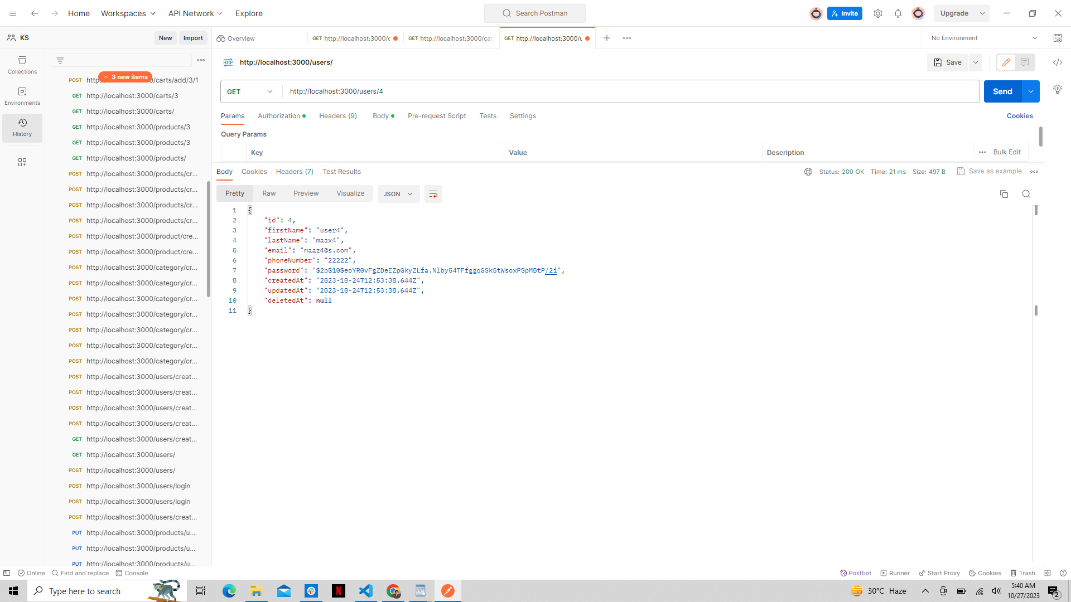

* POST "/login": Authenticates a user and generates an authentication token.
* POST "/createUser": Creates a new user and it's cart
* PUT "/updateUser/:id": Updates an existing user by their ID.
* DELETE "/deleteUser/:id": Deletes a user by their ID.

**/* Products Routes. */**

**Api Endpoint:** [**http://localhost:3000/products**](http://localhost:3000/products)

* GET "/": Retrieves a list of products.
* GET "/:id": Retrieves a product by its ID.
* POST "/createProduct": Creates a new product.
* PUT "/updateProduct/:id": Updates an existing product by its ID.
* DELETE "/deleteProduct/:id": Deletes a product by its ID.

**/* Category Routes. */**

**Api Endpoint:** [**http://localhost:3000/category**](http://localhost:3000/category)

* GET "/": Retrieves a list of categories.
* GET "/:id": Retrieves a category by its ID.
* POST "/createCategory": Creates a new category.
* PUT "/updateCategory/:id": Updates an existing category by its ID.
* DELETE "/deleteCategory/:id": Deletes a category by its ID.

**/* Cart Routes. */**

**Api Endpoint:** [**http://localhost:3000/carts**](http://localhost:3000/carts)

* GET "/": Retrieves a list of carts.

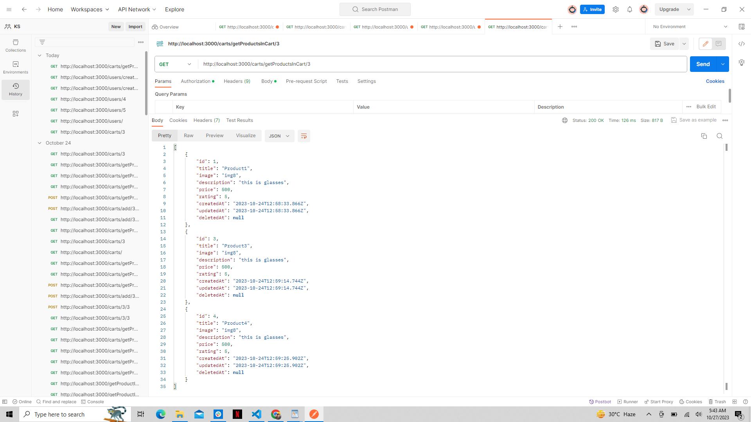

* GET "/:userID": Retrieves a specific user's cart by their user ID.

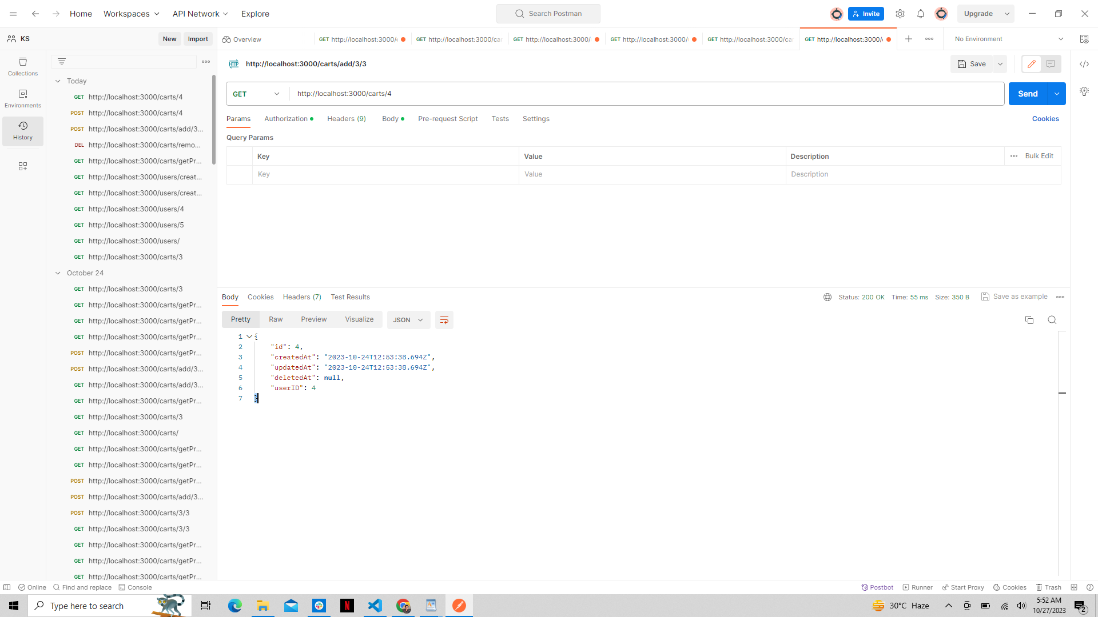

* GET "/getProductsInCart/:cartID": Retrieves products in a specific cart by its cart ID.

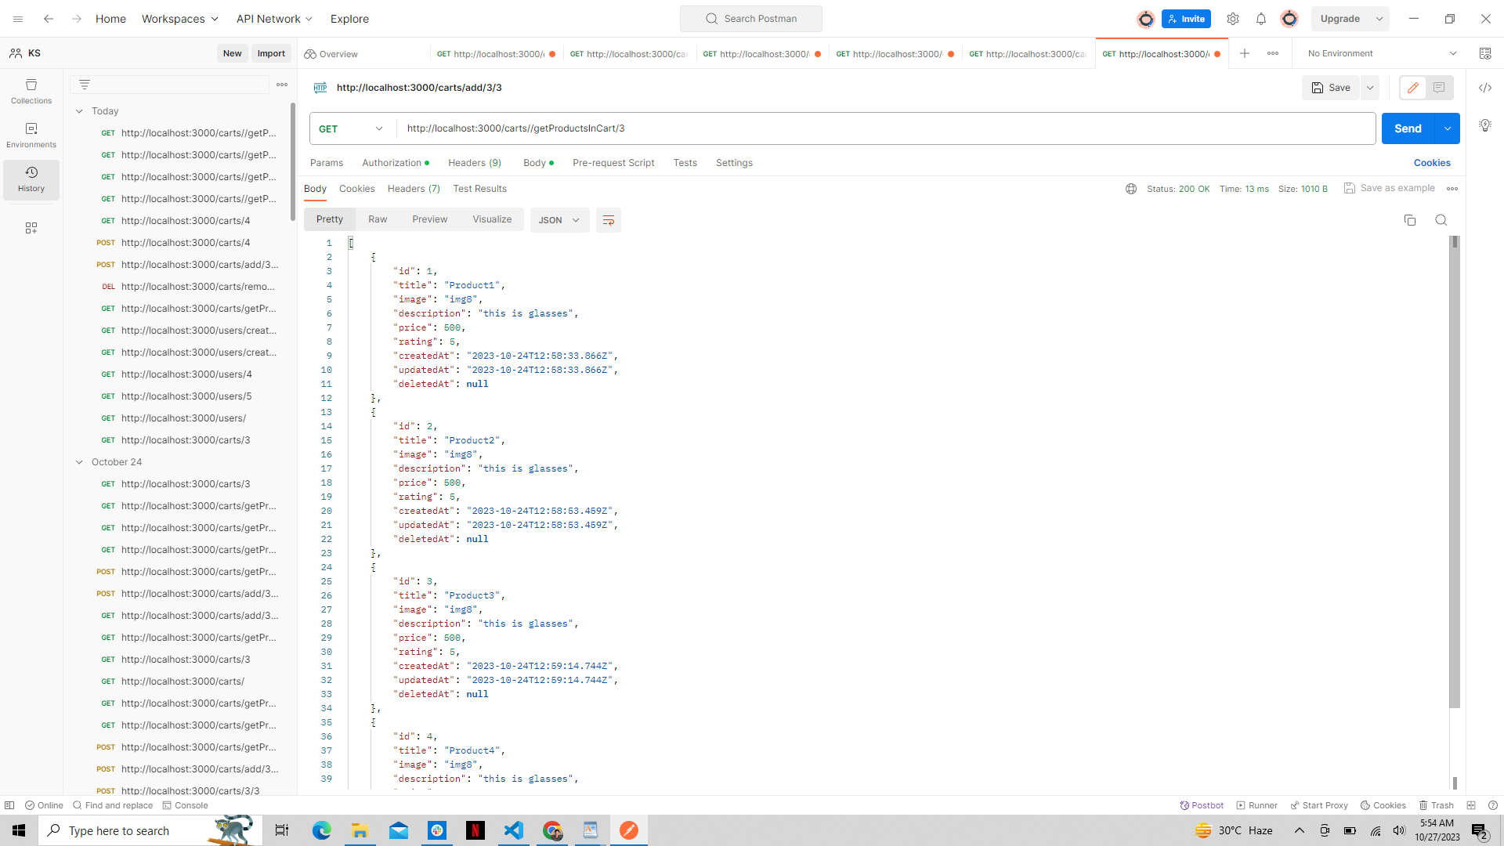

* POST "/add/:userID/:productID": Adds a specific product to a user's cart by their user ID and the product ID.

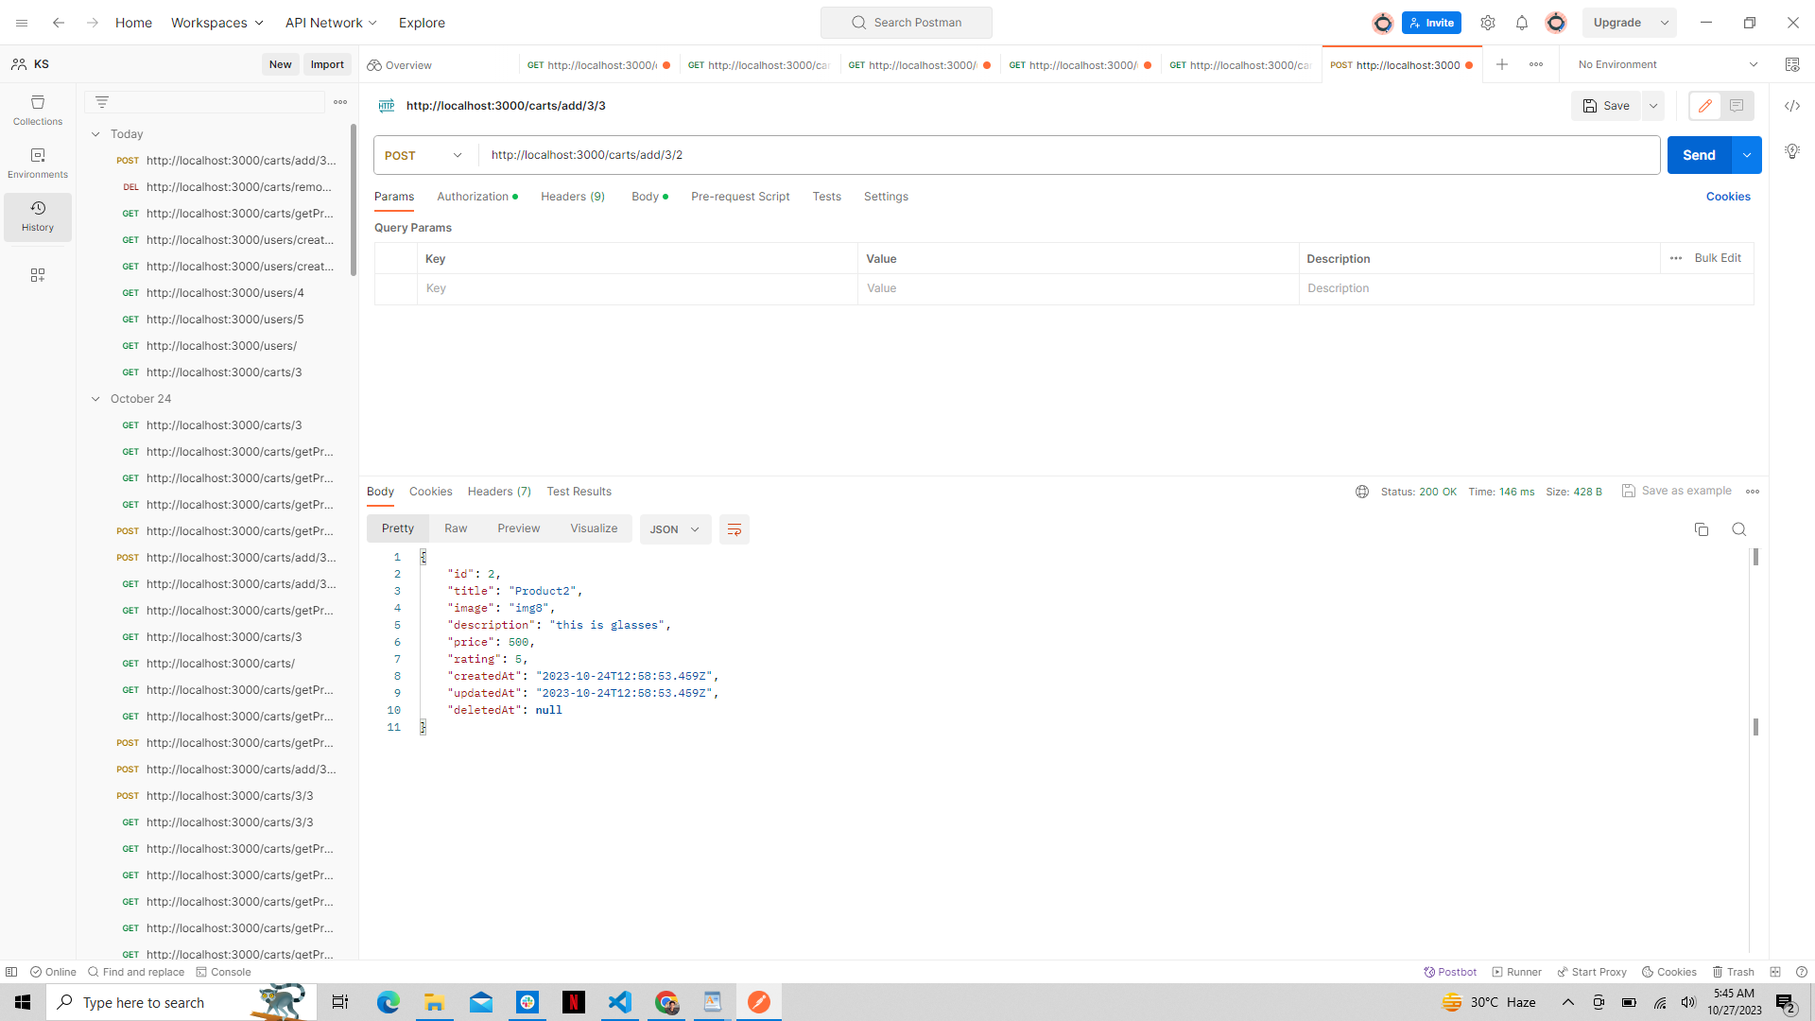

* DELETE "/remove/:userID/:productID": Removes a specific product from a user's cart by their user ID and the product ID.

